**Experiments and results**

* **Logistic Regression**

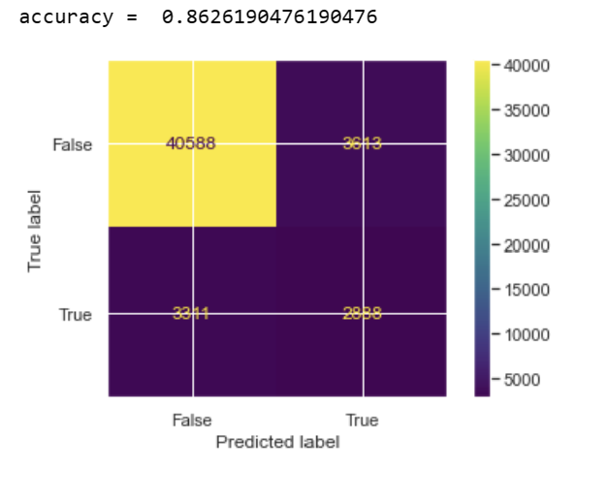

* 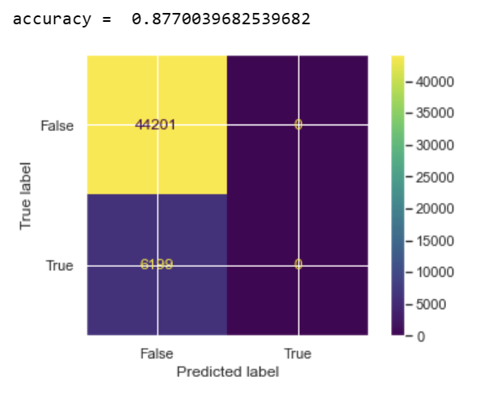**Decision Tree**
* 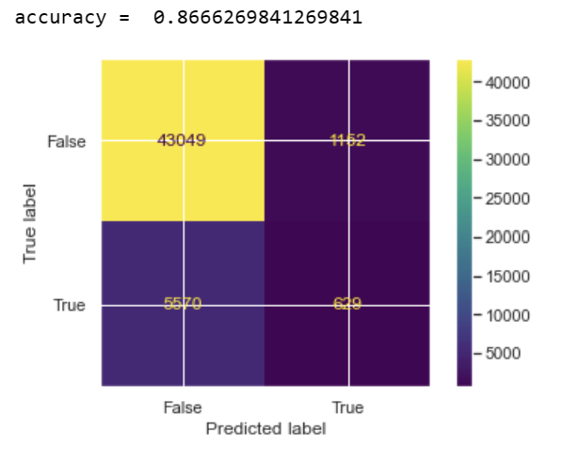 **kNN**
* 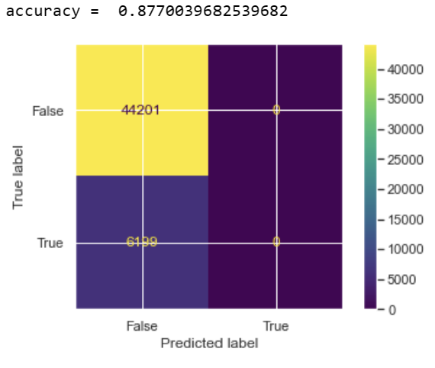**Naïve Bayes**
* **Random Forest Classifier**

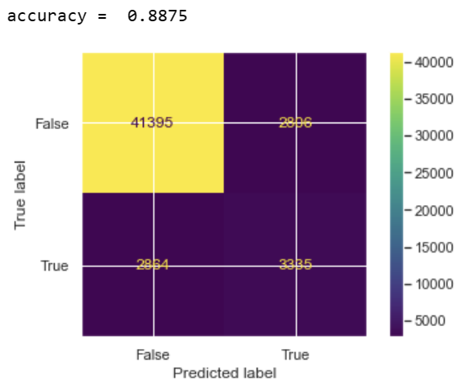

**From the above models Random Forest Classifier is the best with accuracy of 88.75%**